DERSINGHAM PARISH COUNCIL
GRANT ASSISTANCE APPLICATION FORM
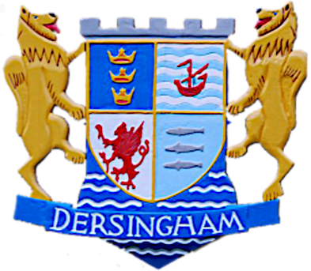
Dersingham Village Centre ,
83 Manor Road,
Dersingham,
King’s Lynn, PE31 6LN

Tel: 01485 541465
Email: bm@dersingham-pc.gov.uk

The Parish Council has a Small Grants budget to help groups set up or provide activities to benefit local people.
It is a small budget. If you need more than £300, please contact the office to discuss your project. In exceptional cases, we may be able to help. We can also direct you to other grants bodies.
You can also contact Norfolk Community Foundation, which administers/manages funding schemes across Norfolk. Visit their website: www.norfolkfoundation.com Telephone: 01603 623958
The Parish Council will assess your application against the following criteria:
• Benefit to parishioners – does your project benefit residents in Dersingham?
• Equal Opportunities – is your project open to all?
• Safeguarding – you will need to have appropriate polices if your project involves working with children or vulnerable adults
• Accessibility – can people with disabilities take part in/benefit from your project?
• Financial need - could the project take place without financial assistance from the Parish Council

Make sure that:
(a) You understand and have completed all sections of this form.
(b) You are prepared to disclose the information requested
(c) You enclose/attach all relevant documents

If you have any queries regarding what can be funded or the information requested, please contact the Parish Office: Tel: 01485 541465 or email: bm@dersingham-pc.gov.uk

After completing the form, return it to the Parish Council by email or post to the addresses above.
We suggest you keep a copy in case of queries.

Section 1
Tell us about your organisation
*Name:
Contact Person:
Address (inc postcode)

Telephone No
Email

*Any payment will be made by BACS to the organisation as shown – please provide your bank details:

Name of Bank: Sort Code: Account Number:

Tell us about your organisation:
Is it a *Registered Charity, voluntary/community group, Social Enterprise, Club?
What do you do or wish to do and who benefits:
* please provide the Registration Number.

Is membership restricted in any way? Yes/No
If yes, please give brief details

Do you have -
Written constitution Yes/No
Equal Opportunities Policy Yes/No
Safeguarding Policy Yes/No
If yes, these should have been adopted recently or reviewed annually, please
enclose copies.
Section 2
About your project
Tell us briefly about your project, what you wish to achieve, who will benefit (eg older people, children, families, disadvantages people) and how the grant will help. We do need to know what percentage of those who will benefit live in Dersingham.

Section 3
Financial
How much will your project cost? £
What funds do you have? £
How much are you requesting from the Parish Council? £
Have you previously applied to the Parish Council? Yes/No
Have you applied to any other funders? Yes/No

Signature of contact named in Section 1
Signature:

Date:

Data Protection
Part, or all, of the information supplied will be held on computer, or filed, in the Parish Council office. This information will be used for the administration of application and grants, and for statistical analysis.
You have the right to see the information we keep and to have any inaccuracies corrected.
Grant applications will be discussed at Parish Council meetings, noted in minutes,
and may also be reported in local press reports and the Village Voice magazine.
We will not disclose personal details without your permission.

